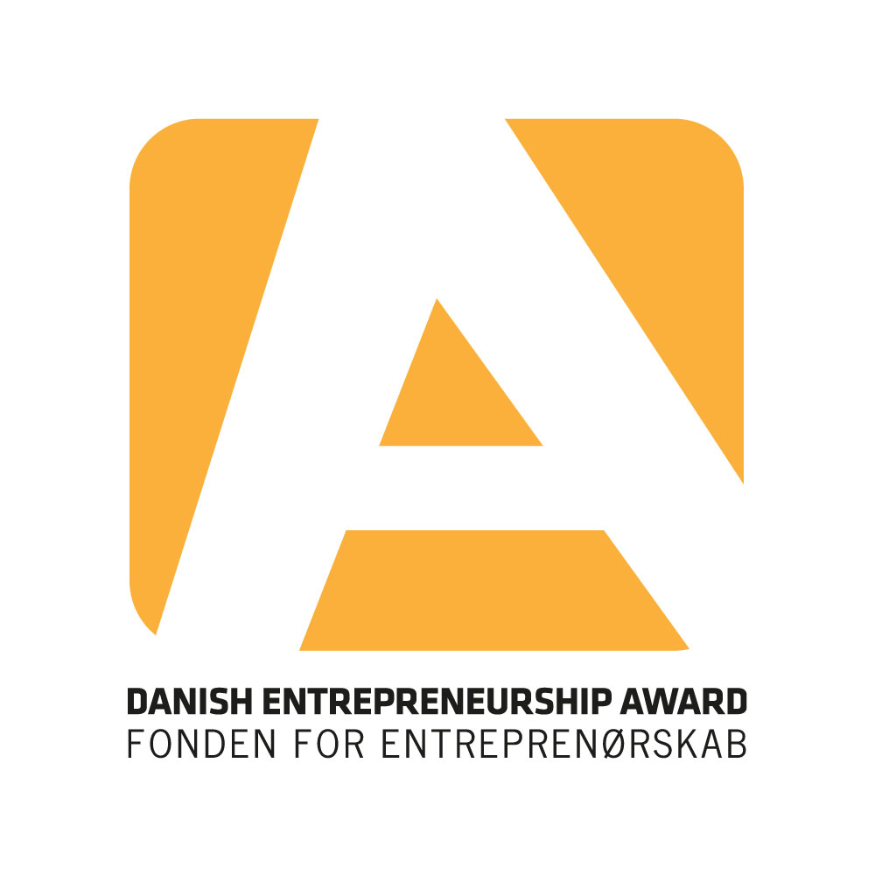

Do you want to win 10,000 DKK for the realisation of your design?
Take the first step and apply to participate in the competition DesignTalent 2018 at the Danish Entrepreneurship Award.

DesignTalent focuses on the growth potential in Danish design. Competent designers from the design industry will assess 15 nominated designers on design and innovation, commercial value, presentation and exhibition. Furthermore, the contestants get the opportunity to show their design to approximately 7,000 participants at the Danish Entrepreneurship Award – a mixture of pupils, students, teachers and businesspeople from the whole country.

What is required in order to apply?
You must be a design student or a newly educated designer (the education must have been completed within the last two years), and you must have at least one physical prototype of your design that you can exhibit on DesignTalent.

How does it work?
You fill out an application form and send it, along with a picture of your design, to award@ffe-ye.dk. The deadline is Tuesday October 23rd 2018 at 12 o’clock – noon. Afterwards, 15 designers will be nominated to participate in DesignTalent – all applicants will receive a message.
At DesignTalent, all nominees will get an exhibition area appointed of 3x3 metres and approximately 10 europallets on which you can build a podium or an exhibition platform. The judges will come at each stand and assess all 15 contestants. The contestants will start out with a one minute presentation of their design and their thoughts about the design. Hereafter, the judges will deliberate, and the winner will be announced on stage during the finale of Danish Entrepreneurship Award.

Besides the prize of 10,000 DKK, the winner will also get a stand on FindersKeepers – one of the leading designer markets in Denmark with the purpose to gather all the best designers and artists and give them the opportunity to present their designs on a highly acknowledged platform.

”The positive response that I have received from all sides at Danish Entrepreneurship Award has given me certainty that my designs are relevant. At the same time, this has given me the courage to move forward and do my best to get my designs out into the world.” Emil Lagoni Valbak, ADAPT, winner of DesignTalent 2015

